Thank you for your assistance in marketing the 2019 EACE Road Trips to the Real World program on your campus!

Included in this toolkit you will find:
• A marketing timeline
• Email templates for faculty, staff and students
• A campus announcement template
• Social media templates

Please also utilize the marketing materials listed below which can be found on the EACE website at: http://www.eace.org/roadtrips

• RTRW 2019 Student Poster
- RTRW 2019 Graphic
- RTRW 2019 Infographic PDF
- RTRW Logo
If you have any questions about the EACE Road Trips to the Real World program or the marketing toolkit please contact your EACE Committee Liaison.

Thank you again for your help!

Suggested Timeline

Key Dates
- Student Registration Opens: Thursday, October 29, 2018 at 12:00 pm EST at www.eace.org/roadtrips
- Student Registration Closes: Friday, December 7, 2018
- Site Visits Take Place: January 3 - 18, 2019

Week of October 28, November 4, November 11, November 18, November 25:
- Send out targeted email communications announcing open registration for the program. Use marketing email and social media templates, and tailor for specific groups.
- Please remember to attach flyer and/or infographic images when possible
  - Examples of Special Groups for Targeted Emails
    - Specific Majors
    - Professional Clubs and Organizations
    - Faculty and Academic Departments
    - Special Student Leaders: (RA’s, OL’s, student workers, etc.)
    - Athletes & Coaches
    - Student Affairs Staff or other Campus Departments
    - Consider students you know well and email individually if there is a site near their hometown or related to their major and career goals

Week of December 2:
- Send out final emails and social media announcements about registration closing on Friday, December 7.

Please note that this is a suggested timeline for marketing the EACE Road Trips to the Real World Program to students on your campus. We understand that you have many responsibilities to juggle and appreciate anything you can do to help market this great program to your students. As a reminder, this program is only available to current undergraduate and graduate students from member colleges and universities.

Marketing Email Templates

Email to Students
Subject Line: Employer Site Visits over Winter Break - Road Trips to the Real World!
Hello (insert audience/group/etc.)

GOT WINTER BREAK PLANS?

Participate in EACE’s Road Trips to the Real World! Road Trips offers college students the opportunity to attend one-day employer site visits for between January 3-18, 2019. Host companies will talk about their organization, industry, internships, and job opportunities This is your chance to get the inside scoop and literally get your foot in the door at 30 participating employers…BUT space is limited and spots fill up VERY quickly, so register now!
The registration deadline is Friday, December 7, 2018. Register at www.eace.org/roadtrips

At each site, you will get an in-depth look at how the company operates and see firsthand the potential internships and jobs that are available. You will also network with employers and get a head start on your career planning. This is an opportunity you do not want to miss!

WHO: Students who are interested in exploring career opportunities. Open to any current undergraduate or graduate student attending a college or university that is a member of the Eastern Association of Colleges and Employers (EACE).
WHAT: An opportunity for students to learn first-hand about a career field, network with employers, and explore internship and job opportunities at 30 companies.
WHERE: Northeast region (Boston, Philadelphia, New York, and D.C. just to name a few!).
WHEN: Registration is open from October 29 – December 7, but sign up early as space is limited. Site visits take place on one day between January 3-18, 2019. View the schedule and register at www.eace.org/roadtrips.
WHY: It will help you to think about life after college and the career paths that are available. After all, it is never too early to start thinking about your career!

THIS YEAR'S SITES INCLUDE:
- American Enterprise Institute, Washington, D.C.
- Arbella Insurance Group, Quincy, MA
- Bentley Systems, Philadelphia, PA
- City Year Inc., Boston, MA
- FBI-New York Office, New York, NY
- Foresters Financial Services, New York NY
- GlaxoSmithKline, East Durham, NY
- HBO, New York, NY
- HubSpot, Cambridge, MA
- Horizon Media, New York, NY
- National Australia Bank, New York, NY
- Penguin Random House, New York, NY
- PLS Logistics, Philadelphia, PA
- Smithers Viscient, Wareham, MA
- Subaru, Camden, NJ
- United Nations Foundation, Washington, DC
- USLI, Wayne, PA
- Vertex, King of Prussia, PA
- Wolf Trap Foundation for the Performing Arts, Vienna, VA
- Yelp, New York, NY

The Road Trips cost $10.00 per site and are non-refundable. Students can sign up for a maximum of 5 site visits as long as they do not conflict on the same day or time. Students must provide their own transportation to and from the site, and are responsible for any incidental expense they may incur.

We look forward to seeing you on a Road Trip this January! If you have questions, please check the EACE website or contact your career center on campus.

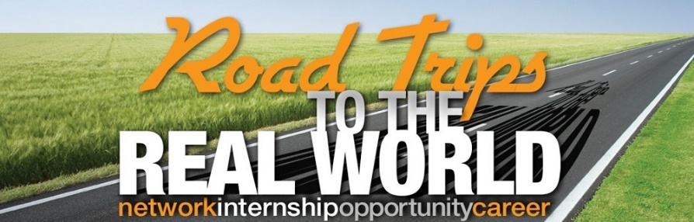

Email to Faculty/Staff/Administrators
Subject Line: Spread the Word – 30 Employer Site Visits over Winter Break!

Dear Faculty and Staff,

Please encourage your students to participate in this exciting winter break career development program - Road Trips to the Real World, sponsored by EACE!

Road Trips to the Real World offers college students the opportunity to attend one-day employer site visits for between January 3-18, 2019. Host companies will talk about their organization, industry, internships, and job opportunities This is a chance for students to get the inside scoop and literally get their foot in the door at 30 participating employers…BUT space is limited and spots fill up VERY quickly, so encourage students to register now!
The registration deadline is Friday, December 7, 2018. Register at www.eace.org/roadtrips

At each site, students will get an in-depth look at how the company operates and see firsthand the potential internships and jobs that are available. Students will also network with employers and get a head start on their career planning. This is an opportunity students do not want to miss!

WHO: Students who are interested in exploring career opportunities. Open to any current undergraduate or graduate student attending a college or university that is a member of the Eastern Association of Colleges and Employers (EACE).
WHAT: An opportunity for students to learn first-hand about a career field, network with employers, and explore internship and job opportunities at 35+ companies.
WHERE: Northeast region (Boston, Philadelphia, New York, and D.C. just to name a few!).
WHEN: Registration is open from October 29 – December 7, but sign up early as space is limited. Site visits take place on one day between January 3-18, 2019. View the schedule and register at www.eace.org/roadtrips.
WHY: It will help students think about life after college and the career paths that are available. After all, it is never too early to start thinking about your career!

THIS YEAR'S SITES INCLUDE:
- American Enterprise Institute, Washington, D.C.
- Arbella Insurance Group, Quincy, MA
- Bentley Systems, Philadelphia, PA
- City Year Inc., Boston, MA
- FBI-New York Office, New York, NY
- Foresters Financial Services, New York NY
- GlaxoSmithKline, East Durham, NY
- HBO, New York, NY
- HubSpot, Cambridge, MA
- Horizon Media, New York, NY
- National Australia Bank, New York, NY
- Penguin Random House, New York, NY
- PLS Logistics, Philadelphia, PA
- Smithers Viscient, Wareham, MA
- Subaru, Camden, NJ
- United Nations Foundation, Washington, DC
- USLI, Wayne, PA
- Vertex, King of Prussia, PA
- Wolf Trap Foundation for the Performing Arts, Vienna, VA
- Yelp, New York, NY

The Road Trips cost $10.00 per site and are non-refundable. Students can sign up for a maximum of 5 site visits as long as they do not conflict on the same day or time. Students must provide their own transportation to and from the site, and are responsible for any incidental expense they may incur.

We look forward to seeing your students on a Road Trip this January! If you have questions, please check the EACE website or contact your career center on campus.

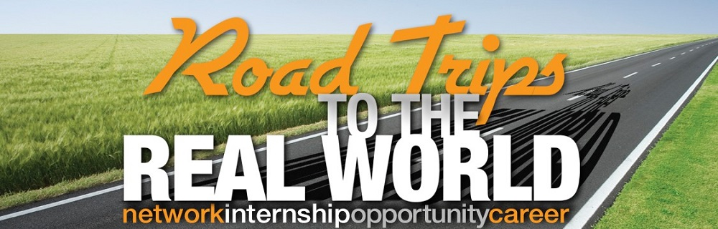

Campus Announcement Template
GOT WINTER BREAK PLANS? Participate in an employer site visit through EACE’s Road Trips to the Real World!
Participate in EACE’s Road Trips to the Real World! Road Trips offers college students the opportunity to attend one-day employer site visits between January 3-18, 2018. Host companies will talk about their organization, industry, internships, and job opportunities This is your chance to get the inside scoop and literally get your foot in the door at 30 participating employers…BUT space is limited and spots fill up VERY quickly, so register now!
The registration deadline is Friday, December 7, 2018. Register at www.eace.org/roadtrips

At each site, you will get an in-depth look at how the company operates and see firsthand the potential internships and jobs that are available. You will also network with employers and get a head start on your career planning. This is an opportunity you do not want to miss!

WHO: Students who are interested in exploring career opportunities. Open to any current undergraduate or graduate student attending a college or university that is a member of the Eastern Association of Colleges and Employers (EACE).
WHAT: An opportunity for students to learn first-hand about a career field, network with employers, and explore internship and job opportunities at 30 companies.
WHERE: Northeast region (Boston, Philadelphia, New York, and D.C. just to name a few!).
WHEN: Registration is open from October 29 - December 7, but sign up early as space is limited. Site visits take place on one day between January 3-18, 2019. View the schedule and register at www.eace.org/roadtrips.
WHY: It will help you to think about life after college and the career paths that are available. After all, it is never too early to start thinking about your career!

THIS YEAR'S SITES INCLUDE:
- American Enterprise Institute, Washington, D.C.
- Arbella Insurance Group, Quincy, MA
- Bentley Systems, Philadelphia, PA
- City Year Inc., Boston, MA
- FBI-New York Office, New York, NY
- Foresters Financial Services, New York NY
- GlaxoSmithKline, East Durham, NY
- HBO, New York, NY
- HubSpot, Cambridge, MA
- Horizon Media, New York, NY
- National Australia Bank, New York, NY
- Penguin Random House, New York, NY
- PLS Logistics, Philadelphia, PA
- Smithers Viscient, Wareham, MA
- Subaru, Camden, NJ
- United Nations Foundation, Washington, DC
- USLI, Wayne, PA
- Vertex, King of Prussia, PA
- Wolf Trap Foundation for the Performing Arts, Vienna, VA
- Yelp, New York, NY

The Road Trips cost $10.00 per site and are non-refundable. Students can sign up for a maximum of 5 site visits as long as they do not conflict on the same day or time. Students must provide their own transportation to and from the site, and are responsible for any incidental expense they may incur.

We look forward to seeing you on a Road Trip this January! If you have questions, please check the EACE website or contact your career center on campus.

Social Media Templates
Facebook Posts
Sample Posts for Week of 10/28:
- Calling all students! Check out this year’s Road Trips to the Real World program- a series of employer site visits where you can learn first-hand about a career field, network with employers and explore internship and job opportunities. #EACE Registration opens noon on 10/29 at www.eace.org/roadtrips

Sample Posts for Weeks of 10/28, 11/4, 11/11, 11/18:
- Student registration for the #EACE Road Trips to the Real World Program is open! This is your chance to get your foot in the door, literally, at 30 participating employers… but space is limited so sign up right away! www.eace.org/roadtrips
- Did you know (insert company) will be hosting an #EACE site visit in (insert city) this January? For more info and to register visit: www.eace.org/roadtrips
- Make your winter break memorable by attending an employer site visit through the #EACE Road Trips to the Real World program. Spots fill up VERY quickly so register now! www.eace.org/roadtrips
- Searching for an internship or planning your full time job search? Employer site visits through the #EACE Road Trips to the Real World Program may provide the future career opportunities you are looking for! Register today- www.eace.org/roadtrips
- Students: Check out this great opportunity to meet employers through #EACE’s employer site visits. Registration is open until 12/7 but spots fill up fast, so register today! www.eace.org/roadtrips
- Don’t miss out on the #EACE Road Trips Program- Registration closes in a week! There are still employers excited to meet YOU, so register today: www.eace.org/roadtrips

Sample Posts for Week of 12/2:
- You only have a few days left to take advantage of this great career exploration opportunity. Registration for #EACE Road Trips to the Real World employer site visits closes this Friday, sign up now! www.eace.org/roadtrips
- Still don’t know what you’re doing during winter break? Jump start your career by attending an employer site visit through #EACE Road Trips to the Real World. You have 2 more days to register! www.eace.org/roadtrips
- The countdown is on, only a few more hours left to sign up for #EACE Road Trips to the Real World! Check out the great industry leaders that you will be able to meet with, then register! www.eace.org/roadtrips

Quick Tips
- Be sure to tag EACE in your Facebook posts. Like our page by searching for “Eastern Association of Colleges and Employers (EACE)”.
- Use #EACE in your posts and any relevant hashtags for your school or career center.
- If mentioning an employer, try to tag their company page in the post.
- Whenever possible, add an image such as the Road Trips logo or the infographic to your post.

Twitter Posts
Sample Tweets for Week of 10/28:
- Students: Got plans for winter break? Check out the #EACE Road Trips to the Real World program! Reg. opens 10/26 www.eace.org/roadtrips
Sample Tweets for Weeks of 11/4, 11/11, 11/18, 11/25:
- Today’s the day! Sign up for #EACE Road Trips to the Real World program. Spots fill up VERY quickly so register now! www.eace.org/roadtrips
- Did you know (insert company) is hosting an #EACE site visit in (insert city) this Jan? Reg info here: www.eace.org/roadtrips
- Students: 30 employers are hosting #EACE Road Trips to the Real World this Jan. View the full list and register: www.eace.org/roadtrips
- Students: Want a head start on your future? Check out the #EACE Road Trips to the Real World Program! Reg info: www.eace.org/roadtrips
- Explore internships & jobs through #EACE Road Trips to the Real World employer site visits. Reg info: www.eace.org/roadtrips
- The #EACE Road Trips to the Real World program could jump start your career! Reg for an employer site visit: www.eace.org/roadtrips
- Students- Registration for #EACE Road Trips to the Real World closes in a week! Don’t miss out: www.eace.org/roadtrips

Sample Tweets for Week of 12/2:
- Students- Don’t miss out! Only a few days left to register for #EACE Road Trips to the Real World! Reg closes 12/7 www.eace.org/roadtrips
- Register for #EACE Road Trips to the Real World yet? Today’s your last chance! Reg. closes 12/7 www.eace.org/roadtrips
Quick Tips:
- Be sure to tag EACE in your tweets. Follow us at @EACEPR
- Use #EACE in your tweets and any relevant hashtags for your school or career center.
- If mentioning an employer, try to tag their company in your tweet.
- Whenever possible, add an image such as the Road Trips logo or the infographic to your tweet.

